Lesson 4: Race, Ethnicity, Culture & Leisure – By Evan Webb
Last week we looked at how individuals marginalized by gender and social class are constrained in their leisure, oppressed by leisure (due to its potential for reproducing oppressive power structures), but also utilize leisure to resist oppression. Granted I left this part mostly to the textbook chapters since they elegantly described these topics. This week I’d like to continue this line of thinking and discuss the leisure experiences of individuals marginalized by their race, ethnicity or culture. Though also a political discussion, I’d also like to not bind this lesson to just politics. Some of what may be described is also sociological and psychological, but centered on multiculturalism and leisure.
North America and Diversity
Race will refer to a set of shared common physical features that often differ due to one’s country or state of origin (e.g., skin pigmentation, eye shape, head form, facial features, stature). Culture, on the other hand, is more socially determined and refers to a set of customs, attitudes, practices, and behaviours that characterize a group of people. “The way we act, the way we talk and the way we socialize are all patterns of behaviour that signify the culture that we have been raised in and to which we belong” (Karlis, 2004, p. 164). In this way culture can have an impact on how we perceive and engage in leisure. Ethnicity will be understood in this Lesson as a unique cultural heritage or set of cultural characteristics that are passed on from one generation to another, often identified by patterns of language, family life, religion, and even leisure customs. Of course, though different, these concepts often overlap. Also, people who are non-Caucasian or non-white in colour in North American countries (and are also not Aboriginal) may sometimes be referred to as a member of a ‘visible minority group’ according to Statistics Canada.

*Chapter 21 of the textbook, a mandatory reading for this Lesson, by Gordon Walker has a summary of some revealing statistics concerning the ethnic makeup of Canada’s population based on data from Statistics Canada. You may want to read up on this.

“Canada is a diverse and pluralistic nation consisting of many different people from many different societies. The multi-ethnic fabric of Canada makes our society interesting, not only in cultural makeup but also in its cultural practice of which leisure is an important part” (Karlis, 2004, p. 163).

“The increase in ethnic diversity in North America is one of the most powerful forces shaping these societies today. As the proportion of the population that demographers classify as white decline in the 21st century, diversity in ethnicity and race and the societal consequences of this diversity will become even more visible” (Russel, 2005, p. 391).
These quotes above signify how diversity in terms of race, ethnicity, and culture are a big part of North American society. This is not surprising as both Canada and the U.S. are countries that have developed through immigration (i.e., an influx of people coming to settle in the country from different nations). Early assumptions of this system raised expectations that various ethnic groups would assimilate into the mainstream culture. Assimilation refers to the idea that the wide variety of ethnicities would homogenize into a common culture that is a combination of ethnic and racial groups. However, what has happened is that Canada and the U.S. have become increasingly pluralistic in which distinctiveness between groups of people in terms of ethnic or racial heritage is present. Pluralism refers to when members of diverse ethnic and racial groups maintain separate participation in their traditional cultures (Russel, 2005, p. 392).
Race, Ethnicity, Culture and Leisure
Ethnic identity affects people’s leisure behaviour and leisure behaviour reinforces a sense of ethnic identity. Right now 6 explanations for why differences in leisure participation exist between ethnic groups will be described below.
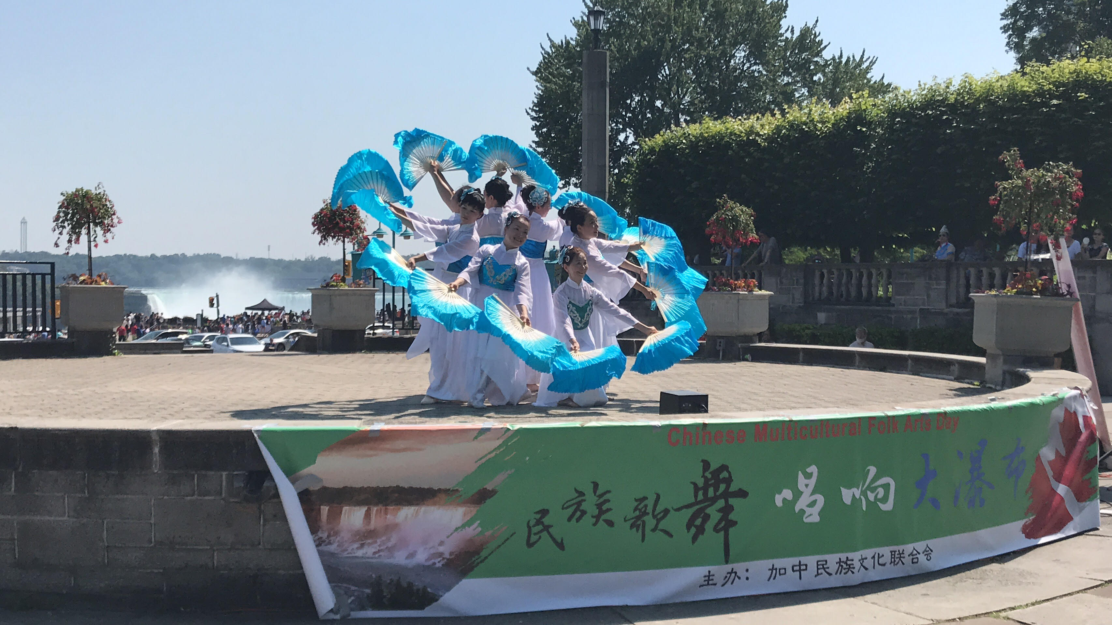
6 Explanations for Differences in Leisure Participation
The leisure of people of different races, ethnicities, and cultures in North America could be seen as quite pluralistic as well. Two theses have been postulated to try and explain why the leisure preferences and participation patterns of different racial and ethno-cultural groups exist. (1) Marginality thesis suggests that ethnic and racial differences in leisure participation are due to a group’s marginal position in society caused by poverty or various consequences of socioeconomic discrimination. In this way, the leisure they pursue would be those opportunities least constrained to them in their position. On the other hand, (2) ethnicity or subcultural thesis proposes that differences in leisure participation patterns are explained by cultural based values, norms, and socialization patterns and one’s leisure is reflective of one’s distinct cultural identity. At the same time this might discourage participation in certain leisure due to a lack of congruence between the activity and one’s cultural identity.
In Chapter 21 of the textbook, Walker describes two discrimination-based explanations of differences in leisure behaviour of people of differences races, ethnicities, and cultures. The first discrimination explanation, (3) personal perceived discrimination suggests that leisure participation is negatively impacted when an ethnic or visible minority group member perceives he or she is being discriminated against either by other recreationists or by recreation agency staff. The second discrimination explanation, (4) institutional discrimination, concerns organizational or community prescribed practices that have a negative or differential impact on members of particular ethnic or visible minority groups but are not motivated by prejudice or malice.
Also described in Chapter 21 of the textbook by Walker, and drawing from work from Kleiber, Walker, and Mannell (2011), are two additional explanations of leisure differences between people of differing ethnicities. (5) Seeking positive emotions or affect refers to participating in specific mood-producing behaviours (i.e., leisure activities) in order to achieve the mood individuals want if they are currently not experiencing that mood (very similar to Optimal Arousal Theory from Lesson 2). It is suggested that the types of moods individuals try to achieve may also be a product of one’s cultural background and thus affect the type of leisure they would participate in (e.g., many European Americans prefer high arousal activities while many Chinese Canadians prefer low arousal activities). (6) Acculturation is also identified as particularly relevant to immigrants and immigrant children. Acculturation refers to the changes experienced by a cultural group or a member of a cultural group as a result of contact with another cultural group. According to Walker in Chapter 21 of the textbook, drawing on work from Barry, Poortinga, Segall, and Dasen (2002), there are 4 results of acculturation based on one’s preference for contact with mainstream culture and one’s preference for maintenance of their heritage culture:
• € €€Assimilation: A person prefers to be absorbed into mainstream culture and sheds their cultural heritage
• € €€Separation: A person prefers to hold on to their cultural heritage and keeps mainstream culture largely at arm’s length
• € €€Integration: A person prefers to maintain his or her cultural heritage and to be involved in mainstream culture
• € €€Marginalization: A person is unable or unwilling to maintain their cultural heritage and is unable or unwilling to be involved in mainstream culture
Whatever effect of acculturation one experiences may also affect the leisure that an immigrant, or a child of an immigrant, participates in (e.g., an assimilated individual may participate in dominant culture leisure activities while a separated individual maintains participation in leisure activities traditional to their heritage culture).
Immigration and Culture Shock
Anyone who has experienced immigration has probably experienced culture shock, a sense of confusion and uncertainty, and at times stress, affecting people exposed to a foreign culture without preparation. According to this week’s reading by Stodolska (2000) many immigrants bring a diverse set leisure participation patterns and customs that may seem out of place or are difficult to engage in in the same way as in their old countries. Many immigrants may even cease doing their preferred leisure activities that were a part of their regular everyday life. However, leisure can also help with culture shock by allowing one to preserve parts of one’s culture while making adjustments to a new culture. In Stodolska (2000), her immigrant research participants found a sense of psychological comfort, stability, and familiarity by engaging in the leisure activities that they started in their home countries. Meanwhile, leisure provides a venue in which one can meet people of the dominant culture and learn about and adjust to the host country (Tirone & Pedlar, 2005).
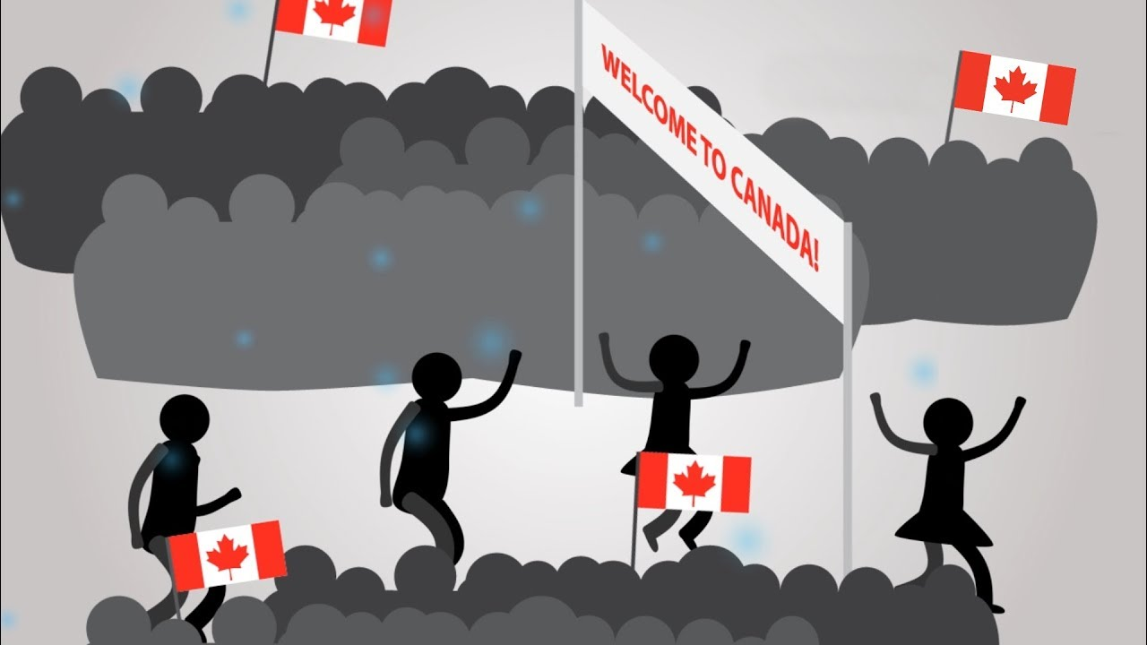
Ethnic Community Organizations
Canada’s multiculturalism policy (i.e., the Multiculturalism Act of 1988) allows the basis for the establishment of ethnic community organizations in the country. Most ethnic groups in Canada have established their own community organizations (Karlis, 2004). These organizations fulfill important roles in these cultural communities such as providing a place of social contact among members, the maintenance of ties to one’s ethnic origins, and the maintenance of one’s cultural and linguistic traditions. Ethnic community organizations often manifest as religious structures (churches, synagogues, mosques, temples), social or community centres, and recreation facilities dedicated to certain cultural groups. These community organizations allow Canadians a context to practice their ethnic heritage including the leisure and recreation of one’s specific ethnicity or culture (e.g., dance groups). The promotion and maintenance of ethnic cultures can be attributed to the existence of these organizations. “The Government of Canada provides a number of financial incentives (e.g., grants) to help support the existence and sustainability of these organizations and their cultural specific programs and recreational activities” (Karlis, 2004, p. 169). However, it is the members of these organizations (immigrants and their descendants), often working in a volunteer capacity, who are responsible for organizing, operating, implementing and ultimately sustaining the ethno-cultural specific services and operations of their ethnic community organization. This leaves the existence of places in which people can practice the leisure activities of their ethnic origin to the efforts of the ethnic community.

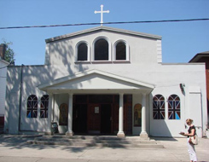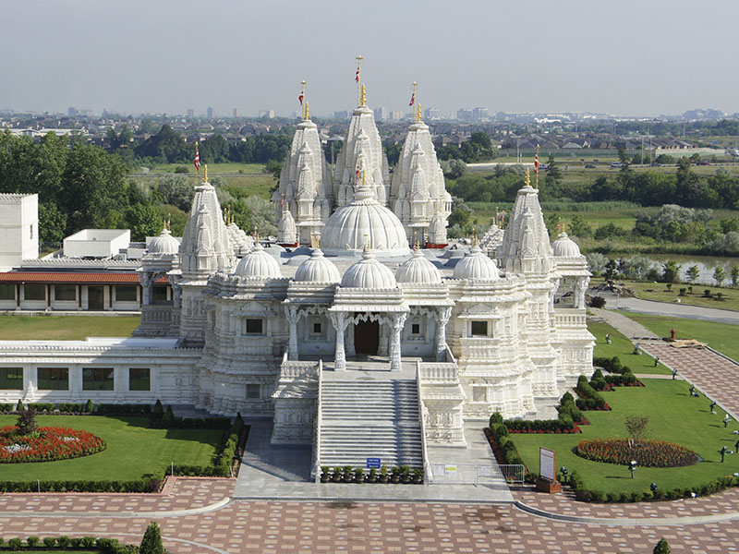

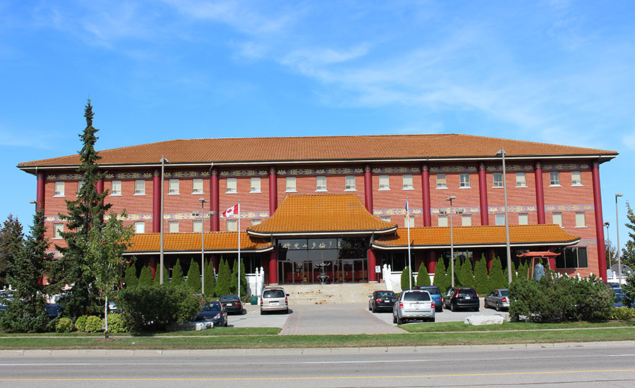

The following link will take you to a list of ethnic organizations that exist in the Niagara region in Ontario (the region in which Brock University is based) who are a part of the Niagara Folkarts Community.

http://folk-arts.ca/festival/open-houses/
Constraints, Motivations, & Benefits of Leisure Participation for People of Different Racial, Ethic, and Cultural Groups
This Lesson will be separated into describing the constraints, motivations, and benefits multi-ethnic and multicultural individuals experience towards their leisure. Constraints (factors preventing leisure participation and enjoyment) and motivation(factors that compel one to engage in leisure) have already been described at length in Lesson 2. Benefits will refer to an advantage or profit gained from something. Leisure participation can result in a wide variety of physical, cognitive, and social benefits. These can be considered three interrelated concepts: (1) motivations can help one overcome constraints; (2) benefits can be what motivates individuals to act; and (3) constraints can prevent one from receiving benefits.
So without further ado, what are the constraints, motivations, and benefits present within the leisure experiences of individuals of different races, ethnicities, and cultures?
Constraints
In Lesson 2 we discussed 3 kinds of leisure constraints (1) intrapersonal, (2) interpersonal, and (3) structural. According to Walker in Chapter 21 of the textbook several of the 6 explanations for leisure behaviour in diverse ethnic groups (which also explains lack of leisure participation) can fit into these types of constraints. Specifically he explains that: marginality thesis and both perceived personal andinstitutional discrimination appear to be structural constraints. Meanwhile, ethnicity/subcultural thesis and acculturation seem to be intrapersonal constraints as they fall into an individual’s psychological state.
Research by Pawlick and Karlis (1998) argues that, while leisure is important for immigrant women in Canada, they often put much priority on family and home-life and various religious and cultural values may limit their leisure participation. McCue (1984) argues that a lack of leisure involvement in older aged immigrants is often a result of language and communication barriers and that they are also less likely to engage in leisure if they feel there is potential for intolerance and discrimination towards them. Lack of opportunities and limited accessibility to leisure services is the primary obstacle that aged immigrants face (Karlis, 2004).
In this Lesson’s mandatory reading by Stodolska (2000), several qualitative findings were reported pertaining to the constraints that the study’s participants of Polish immigrants to Canada have experienced in relation to their leisure participation and enjoyment. Several of these constraints were described as a result of environmental changes that were directly responsible for the changes they had introduced to their leisure behaviours post immigration (these bare many similarities to what could be considered structural constraints).
• Some of their preferred regular activities were no longer available in the new country
• Some of their preferred regular activities turned out to be too expensive in the new country (particularly taking into consideration the fact that many leisure activities were subsidized heavily in the old communist system)
• Some leisure spaces and activities held within were perceived to be too dangerous (e.g., wilderness areas in Canada, unmarked trails, and abundance of potentially dangerous wildlife appeared more dangerous and less supervised than outdoor venues in Poland)
• Some activities were too time-consuming or simply no longer fit new lifestyles of immigrants (settling into a new country can be very busy and time consuming on its own).
Several of these constraints were described to be a result of shattered social networks (which bares a similarity to what could be considered interpersonal constraints). Described in the article is that Eastern Europeans tend to attach substantial importance on frequent contacts with extended family members. Given that newcomers become separated from most of their relatives and childhood friends, certain types of leisure such as socializing may become severely constrained.
Another constraint to leisure participation in this article was the onset of post-arrival depression (a barrier which could be understood as an intrapersonal constraint due to its existence as an individual’s psychological state). This had induced participants into abandoning many of their old pastimes and neglecting to acquire new ones. This was described as being caused by a variety of factors including:
•€€€€€€€€€lack of language skills,
•€€€€€€€€€fear of the new environment,
•€€€€€€€€€lack of social networks
In Tirone and Pedlar’s (2005) article (another mandatory reading this Lesson) on second generation immigrants (children of immigrants), from South Asia, several constraints were highlighted that are unique to these individuals. Participants of this study were visible minorities, had a close link to their ethnic heritage, and had spent most of, if not all of, their lives in Canada. In home, family, and traditional community leisure spaces (in which they mixed with family and with people whose heritage was similar to their own)
• There was a high expectation and obligation to sustain family and ethnic traditions and to spend time with their immediate and extended family members - some participants even indicated feeling dissatisfaction and distress due to these pressures to remain close to home all the time

In dominant culture leisure spaces several constraints were also experienced by these children of South Asian immigrants:
• Involvement with youth of the dominant culture was a source of friction with their parents as they perceived dominant youth as disrespectful of authority and lacking parental guidance and control
• Immigrant parents feared their children would get into trouble because of their involvement with peers of the dominant culture
• Parents disapproved of many of these dominant leisure venues (e.g., clubs)
• Leisure experiences in places of dominant culture carried the potential to experience racism and discrimination that controlled access to, and enjoyment of, some leisure
Actual discrimination and the potential for discrimination are major constraints towards leisure participation and leisure enjoyment for individuals of minority races, ethnicities, cultures and visible minorities. Discrimination of visible minorities is currently a major issue affecting both Canada and the United States. Particularly in the United States, animosity between black Americans and police officers seems to be at an all-time high with stories consistently being reported in the news concerning black people being unjustifiably shot by police offers and other various struggles and abuses of rights. Can this pervasive issue also affect leisure and the enjoyment of leisure by visible minorities?

Embedded below is a short article with a video (4:50 - start 40 seconds in). This is a recent incident from Grand Rapids, Michigan in the U.S. Depicted are five black male youth (ages 12 to 14) who were returning home from playing basketball when the local police held them at gunpoint for “fitting a description”. You even hear one of the boys sobbing while lying on the ground. This is especially disheartening for those to who recognize that this is not an isolated incident, but simply one that was archived via video.

*This video may be a bit distressful but I recommend giving it a watch

“At the wrong place at the wrong time”
http://detroit.cbslocal.com/2017/04/24/body-camera-footage-shows-officer-pointing-gun-at-5-unarmed-black-kids-video/
Things to notice:
• Black youth (ages 12-14) returning from a basketball game, held at gun point for “fitting a description”
• Mother scolds son for going to the park – “this is why I don’t let y’all go nowhere”
• Police indicates the kids were just “at the wrong place at the wrong time”

Questions to ask:
• Is playing basketball during daylight, outside school time, the wrong time? When is the right time for these youth?
• Does this constitute a constraint to leisure and access to open space? Is this constraint unique to racial/ethnic/cultural/visible minorities?
• What is the true state of play for racial/ethnic/cultural/visible minorities when a black youth is scolded by their parent not because they did anything wrong while playing, but were suspected of doing something wrong?
• How do we truly embrace social equity in leisure when youth of color face barriers that precede access to open space?
Motivations
“In the same way that leisure constraints may vary both within and among ethnic and visible minority groups, so too can leisure motivations” (Walker, 2013, p. 200).
According to Walker in Chapter 21 of the text, leisure attitudes (one’s feelings or thoughts towards leisure) can vary across ethnic and visible minority groups. For example, many from western cultures value and seek out free time more than those from non-Western cultures.
A study of South Asian Canadians teens with immigrant parents found that leisure preferences reflected an adherence of South Asian cultural traditions and thus a preference for, and much participation occurred, in leisure activities of their ethnic origin (Tirone & Pedlar, 2000). There also exists a strong preference to participate in the leisure activities of one’s ethnic culture as was found in a study of a Greek community in Toronto, ON (Karlis, 2004). This was also found in a study by Bolla and Dawson (1990) with Lebanese, Chinese, Italian, Polish, and Jamaican communities in Ottawa though their specific community organizations played a vital role in providing those ethno-cultural leisure pursuits. Tirone and Pedlar (2000) also found that some South Asian teens in their study preferred and participated in leisure activities not of their ethno-cultural origin. Many children of immigrants are found to assimilate into the mainstream culture and may end up participating in these types of leisure activities.
Also described in Chapter 21 is the idea of self-construal, a concept concerning how people think of themselves in relation to others.
• € €€An independent self-construal concerns valuing uniqueness, one’s personality traits, and asserting oneself in a crowd – this way of thinking is typical in Euro-North Americans
• € €€An interdependent self-construal concerns valuing belonging, external attributes (roles and status), and restraining (as opposed to asserting) oneself – this way of thinking is typical in places such as Asia and Africa

These different self-construals have been found to differentiate the leisure motivations of people of different races and ethnicities. For instance, Walker describes in Chapter 21 a study by Walker, Deng and Dieser (2001) in which it was found that the motivations of Euro Canadians visiting a national park were: looking to experience nature, peace, and calm and being free to make their own choices – which is quite telling of an independent self-construal. Contrastingly, Chinese Canadians in the same study reported wanting to feel a part of the group, and be perceived as humble and modest by their companions – which signifies an interdependent self-construal.
*As an aside…we often see this self-construal manifest in several ways. When we watch sports broadcasts in Canada and the U.S. we are often fixated on the performances of certain key players (e.g., MVP; the night’s 3 stars) on a team and a player’s stats. In other countries characterized by an interdependent self-construal, their sports broadcast are often fixated on the team and their collective performance rather than the performances of each individual player…now back to the topic.
In the article by Stodolska (2000), you’ll notice that some participants were motivated to participate in new leisure activities that were characteristic of their new country, Canada. Many of the participants were motivated to expand their leisure repertoire (e.g., outdoor activities, exercise activities) and were able to take advantage of the opportunities available to do so. For some of the immigrants in this study, engaging in these new leisure activities constituted an avenue for a quick and relatively pleasant way to assimilate into the new culture and society. Participation in mainstream leisure activities had also been motivated at least partly by a desire to:establish or expand their social networks; to improve relations with mainstream coworkers; and to identify themselves with a desired new way of life.

Stodolska (2000) also reports that many participants continued to engage in their old activities:
• € €€Participation in leisure activities popular in their home country provided them with a sense of psychological comfort and connection with things that were known, familiar, safe, and related to their established ways of life.
•€€ €€Participation in activities that they use to do in their old country gave immigrants a sense of connection with their past - and also it provided an opportunity to recapture certain elements of their way of life back in the home country.
• € €€Traditional activities also served as a means of distancing oneself from the problems associated with life in a foreign country, from the stress of unfamiliar surroundings, from discrimination, and from adaptation-related hardships (this bares similarities to Iso-Ahola’s escape dimension of motivations behind one’s leisure behaviours from Lesson 2)
Stodolska’s (2000) article also presents 3 themes that provided insight into the reasons that underlie the observed changes in the leisure patterns of her immigrant research participants – but likely apply to the leisure participation patterns of many immigrant groups as well.
Theme 1: The Importance of Latent Demand (demand that was not being met before)
After having settled in the new country, immigrants found themselves released from constraints that had blocked their participation in desired activities back in the old country - it is the removal of constraints in the new country that triggers participation
• € €€For instance: Because participation in all other outdoor and exercise-oriented activities (besides downhill skiing and hiking) was severely limited in Poland, after their settlement in Canada, Polish immigrants tended to begin participation in these activities

Theme 2: The “Forbidden Fruit” Effect
This refers to activities that were forbidden or practically unattainable in their old countries but immigrants’ move to their new countries has subsequently lifted these restrictions and constitutes a motivation for participation. Unlike latent demand, the forbidden fruit effect may occur in an absence of any such previous desire to engage in the activity. An immigrant is drawn to these activities just for the sake of doing things they had never tried before and were not able to try before.
• € €€This explains the high number of sporting and outdoor recreation activities that Stodolska’s Polish immigrant participants started after coming to Canada but quit shortly thereafter

Theme 3: Demonstration Effect
After having settled in their new country, immigrants discover that particular activities are immensely popular among the mainstream or are associated with people of high social status and a desirable way of life. Thus immigrants might attempt these activities in order to do what is “trendy” or do what others do in a new country.
• € €€This explained why most of Stodolska’s participants took up fishing after having moved to Canada despite never fishing back in Poland
Benefits
Considering that enhancing one’s sense of ethnic identity can be a benefit in and of itself (I certainly think so), leisure can certainly contribute to this. Walker, in Chapter 21 of the textbook, explains that ethnic identity can be enhanced by interacting with others of one’s culture during leisure and engaging in activities characteristic of one’s ethnic culture such as: eating their ethnic foods, listening to their ethnic music, and attending their ethnic movies. According to Karlis (2004) ethnic community organizations, and often the ethnic festivals held by these organizations, are venues in which many people can connect to their heritage and engage in their ethno-cultural leisure activities.
In Tirone and Pedlar’s (2005) article, conducting research with second generation immigrants (children of immigrants), benefits received by the youth engaging in Home, Family, and Traditional Community Leisure spaces included:
• € €€Mixing with individuals who were an important source of support and comfort
• € €€Providing participants with a protective social network and colleagues who shared their sense of interdependence with the South-Asian community
• € €€The development of an appreciation for their traditional roots
• € €€A leisure context free from discrimination and racism
• € €€Leisure experiences that are traditional cultural practices not available to enjoy outside of their minority communities and families (e.g., traditional dance and music)

Benefits received by the youth engaging in Dominant Cultural Leisure Spacesincluded:
• € €€An opportunity to experiment with leisure that they could not access in their homes or with their minority-group friends (e.g., clubs, sports venues, places where friendships occurred with white Canadians)
• € €€A growing understanding of diversity and appreciation of diversity by participants’ dominant group peers

In Diverse Leisure Spaces and Places where the study’s South Asian participants could be involved in leisure spaces with a variety of minority ethnic groups and experience the sharing of many different cultural practices:
• € €€Participants could interact with peers from other minority groups with ease
• € €€These contexts were free from racism often occurring in dominant culture places
• € €€Minority friends from other cultures were more likely to understand constraints faced by participants (such a racism)
• € €€There was potential to immerse oneself in a rich diversity of leisure experiences that extended their leisure repertoire, and provided opportunities for unique forms of leisure
Programs Aimed at Disadvantaged Youth
In Lesson 3a I made reference to my own research being in youth recreation. Through my research I’ve uncovered several examples of youth programs aimed at particular cultural minorities that provide significant benefits for them.
One of these programs is the Refugee Sport Club (RSC). This organization serves refugee youth of various cultural origins who have relocated to Lansing, Michigan, United States (Whitley & Gould, 2011). The purpose of the organization is to teach respect, teamwork and leadership and to have these youth build relationships with the adults leading the program who can fill in as positive role models and mentors in their lives. The adult leaders in this program help to empower the young refugees within the RSC.
Other organizations exist that cater to aboriginal youth such as Right to Play. The basic operation of these organizations is to have these youth engage in various games and sports (e.g., hockey) designed around, and focused on, their positive psychosocial development into adulthood. Aboriginal people represent a very disadvantaged segment of North American society who are often trapped in a cycle of institutional discrimination, poverty, and low socio-economic standing. Unfortunately, I haven’t been able to dive too deeply into Leisure and Aboriginal People in Canada and won’t be able to do so for the duration of this short course. If any of you want to learn more about Leisure and Aboriginal people feel free to read Chapter 22 of the course textbook which is devoted to the topic and is a good read. *This could perhaps be a good essay topic as well.
Though some youth recreation organizations have achieved success with benefitting aboriginal youth, many are unable to achieve significant change. A lot of criticism has arisen around the use of Eurocentric sport and activities with Aboriginal youth and how the use of these forms of recreation may not resonate well with them. What is ignored here is that aboriginal people have a rich cultural history of their own and a potential set of activities and settings that may resonate better with them. I then discovered Project George operating out of Northern Ontario.
Project George is a program aimed at Moosecree youth, a population that regularly experiences poverty and is susceptible to getting involved with substance abuse and violence. This program has been successful with helping to build confidence in the young Moose Cree youth and to resist crime and substance abuse behaviours. As opposed to Eurocentric activities, youth learn skills and participate in activities widely utilized by their ancestors (many of which are forgotten arts by this point) in a more natural wilderness setting which use to be the land that their ancestors thrived in. Please watch this amazing video embedded below to learn about this simple yet innovative program aimed at disadvantaged aboriginal youth.
http://www.moosecree.com/projectgeorge/index.html
Conclusion
You should all read Chapter 21 of the textbook written by Walker. I especially recommend looking at the portions that describe Scott’s (2005) suggestion of 4 ways in which public parks and recreation agencies can unintentionally commit institutional discrimination (p. 199), and the 3 suggestions current leisure practitioners should consider when planning and managing recreation programs, services, and facilities for members of ethnic and visible minority groups. This might be useful for your upcoming second Reflection questions!
In addition to these recommendations, another 5 recommendations have been put forth by Karlis (2004) for leisure and recreation practitioners to enhance the scope of services to address the needs of Canada’s multicultural populations more effectively:
1. Have an understanding of the notional of multiculturalism, pluralism and diversity
2. Have a general understanding of the nature of the ethnic cultures that shape their respective multicultural society, and an even better understanding of the specific ethnic culture of the recreation participant
3. Have an understanding of the values of the ethnic participant
4. Have a good understanding of the recreation resources available within the public, commercial and volunteer sectors of society
5. Be empathetic to the needs and situation of ethnic clients

To serve the ethnic leisure needs of Canada’s multicultural citizens, the leisure service provider must understand the “cultural context” of the leisure participant or potential participant.

